

Economics

SAC 3.1 UNIT 3 OUTCOME 3 PRACTICE

You will have 45 minutes to complete this task plus 5 minutes reading time

Teacher: Mr. Daniel Charles

The total SAC contributes to 25/100 of SAC marks allocated for Unit 3.

Allowed materials for this task include:
- Pens, calculator, pencils, rulers, erasers, highlighters

Name ____________________________________________

Note: The grade or score for this task is only part of the internal assessment for this Unit. Your total School-assessed Coursework score may change as a result of statistical moderation by VCAA.

Grade/Score: ______ Satisfactory Completion? S/N: ______
(Provisional)

Section A – multiple choice questions

Question 1

 | $Billions
Credits in merchandise trade | 200
Debits in merchandise trade | 100
Net services | 40
Credits in net primary income | 100
Debits in net primary income | 140
Net secondary income | -20

The balance on goods and services (BOGS) would be:

- $340 billion
- $80 billion
- $140 billion
- $300 billion

Question 2
Which of the following would have negative impact on the current account balance?

- An increase in XPI relative to MPI
- An appreciation of the AUD against the TWI
- An increase in economic growth in China
- A decrease in net foreign debt

Question 3
Which of the following would not have a positive impact on international competitiveness?
- Australian inflation rising relative to our trading partners
- Achieving economies of scale
- Improvements multifactor productivity in Australia
- Lower company tax rates in Australia

Question 4
Which of the following would be a credit in the financial account of the balance of payments?
- Dividend payments from an Australian firm to overseas investors
- An Australian bank lending $1 million to a US resident
- A Japanese tourist taking a holiday in Australia
- A Chinese investor buying shares in the Australian share market

Question 5

A depreciation of the exchange rate would have the following impact on an economy

- Increase demand inflation, decrease cost inflation, reduce cyclical unemployment
- Increase demand inflation, increase cost inflation, reduce cyclical unemployment
- Decrease demand inflation, decrease cost inflation, reduce cyclical unemployment
- Increase demand inflation, increase cost inflation, increase cyclical unemployment

Section B – Structured questions

Question 1 (10 marks)

Consider the following data from the Australian and USA economy:

Australian Cash rate (interest rates) over last 12 months

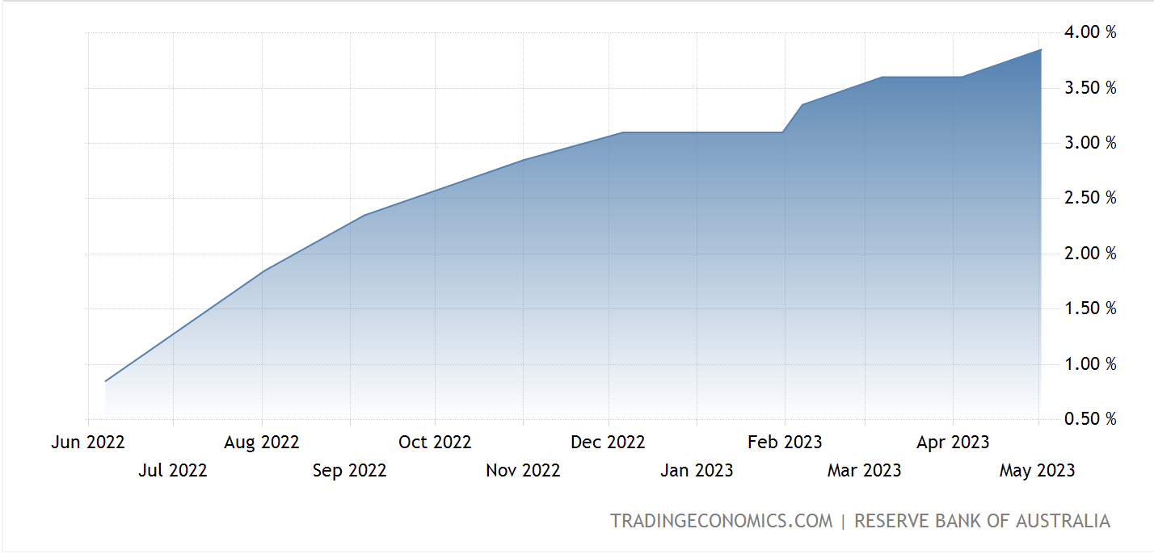

USA Fed rate (interest rates) over last 12 months
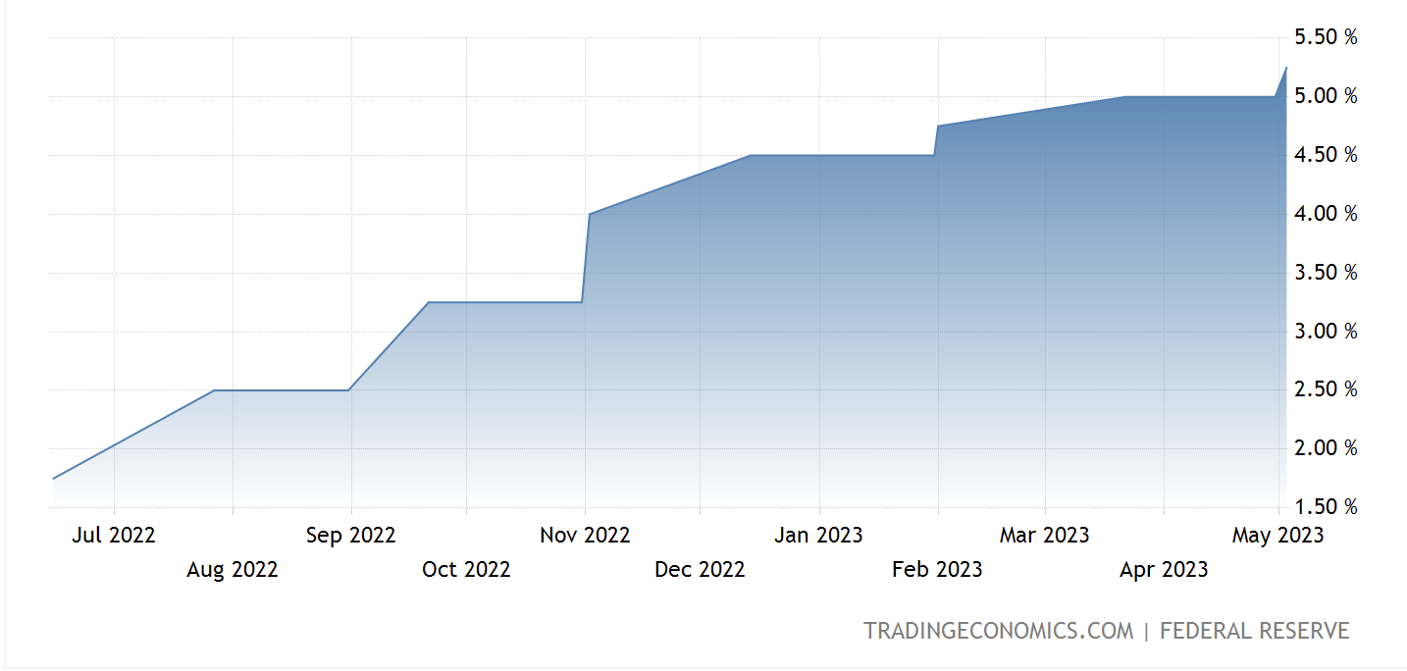

a. Referring to data on page 4, explain the effect that the relative interest rate differential between Australia and the USA would have on the value of the Australian currency ($AUD).
3 marks
____________________________________________________________________________________________________________________________________________________________________________________________________________________________________________________________________________________________________________________________________________________
____________________________________________________________________________________________________________________________________________________________________________________________________________________________________________________________________________________________________________________________________________________
__________________________________________________________________________________________________________________________________________________________________________

b. Explain how currency speculation and Australia’s credit rating can impact the value of the Australian currency.
3 marks
____________________________________________________________________________________________________________________________________________________________________________________________________________________________________________________________________________________________________________________________________________________
________________________________________________________________________________________________________________________________________________________________________________________________________________________________________________________________________________________________________________________________________________________________________________________________________________________________________________________________________________________________________________________________________________________________________________________________________________________________________________________________________________________________________
c. Explain how a movement in the Australian exchange rate can have a positive influence on aggregate supply and the goal of strong and sustainable economic growth.
4 marks
____________________________________________________________________________________________________________________________________________________________________________________________________________________________________________________________________________________________________________________________________________________
____________________________________________________________________________________________________________________________________________________________________________________________________________________________________________________________________________________________________________________________________________________
____________________________________________________________________________________________________________________________________________________________________________________________________________________________________________________________________________________________________________________________________________________
____________________________________________________________________________________________________________________________________________________________________________________________________________________________________________________________________________________________________________________________________________________

Question 2 (5 marks)
a. Define what is meant by the terms of trade and explain how a change in the production costs of trading partners can influence the terms of trade.
3 marks
____________________________________________________________________________________________________________________________________________________________________________________________________________________________________________________________________________________________________________________________________________________
____________________________________________________________________________________________________________________________________________________________________________________________________________________________________________________________________________________________________________________________________________________
____________________________________________________________________________________________________________________________________________________________________________________________________________________________________________________________________________________________________________________________________________________

b. Outline the effect that a favourable movement in the terms of trade might have on livings standards in Australia.
2 marks
____________________________________________________________________________________________________________________________________________________________________________________________________________________________________________________________________________________________________________________________________________________
____________________________________________________________________________________________________________________________________________________________________________________________________________________________________________________________________________________________________________________________________________________

Question 3 (5 marks)
a. Explain how international trade can lead to an increase in productive efficiency and lower prices in the Australian economy.
3 marks
____________________________________________________________________________________________________________________________________________________________________________________________________________________________________________________________________________________________________________________________________________________
____________________________________________________________________________________________________________________________________________________________________________________________________________________________________________________________________________________________________________________________________________________
____________________________________________________________________________________________________________________________________________________________________________________________________________________________________________________________________________________________________________________________________________________

b. Describe one structural influence on Australia’s current account balance.
2 marks
____________________________________________________________________________________________________________________________________________________________________________________________________________________________________________________________________________________________________________________________________________________
____________________________________________________________________________________________________________________________________________________________________________________________________________________________________________________________________________________________________________________________________________________

Question 4 (5 marks)
a. Distinguish between net foreign debt and net foreign equities.
3 marks
____________________________________________________________________________________________________________________________________________________________________________________________________________________________________________________________________________________________________________________________________________________
____________________________________________________________________________________________________________________________________________________________________________________________________________________________________________________________________________________________________________________________________________________
____________________________________________________________________________________________________________________________________________________________________________________________________________________________________________________________________________________________________________________________________________________

b. Explain how a depreciation of the exchange rate can make have a negative impact on net foreign debt.
2 marks
____________________________________________________________________________________________________________________________________________________________________________________________________________________________________________________________________________________________________________________________________________________
____________________________________________________________________________________________________________________________________________________________________________________________________________________________________________________________________________________________________________________________________________________

Extra writing space
____________________________________________________________________________________________________________________________________________________________________________________________________________________________________________________________________________________________________________________________________________________
____________________________________________________________________________________________________________________________________________________________________________________________________________________________________________________________________________________________________________________________________________________
____________________________________________________________________________________________________________________________________________________________________________________________________________________________________________________________________________________________________________________________________________________
____________________________________________________________________________________________________________________________________________________________________________________________________________________________________________________________________________________________________________________________________________________
____________________________________________________________________________________________________________________________________________________________________________________________________________________________________________________________________________________________________________________________________________________
____________________________________________________________________________________________________________________________________________________________________________________________________________________________________________________________________________________________________________________________________________________
____________________________________________________________________________________________________________________________________________________________________________________________________________________________________________________________________________________________________________________________________________________

